⚠️ WORKING PAPER – STRICT COPYRIGHT RESTRICTIONS
Preliminary working paper. Any use—including citation, copying, or distribution—requires prior written permission from the authors. Unauthorized reproduction or commercial exploitation is explicitly prohibited. (December 2025 | mail@error.wtf)

Gravitational Phase Coupling in Quantum Systems:
A Unified Framework for Testing SSZ Predictions

Paper D — Master Document

Lino Casu, Carmen Wrede
Independent Researchers • mail@error.wtf
December 2025

CORE CLAIM
SSZ predicts a deterministic, geometry-coupled phase drift ΔΦ = ω × ΔD × t that is principally compensable. Current transmon qubits provide robust upper bounds; optical atomic clocks are the gold standard for direct detection.

Repository: https://github.com/error-wtf/ssz-qubits

Abstract
The Segmented Spacetime (SSZ) framework predicts that quantum systems at different gravitational potentials experience deterministic phase drifts arising from differential time dilation. This paper unifies our three-paper series (A–C) into a single experimental framework.
We establish the theoretical basis—the SSZ time-dilation factor D = 1/(1+Ξ), the segment density Ξ(r), and the core phase-drift equation ΔΦ = ω ΔD t—and derive explicit numerical predictions. The with/without compensation protocol is presented as the strongest discriminator between SSZ and confounds, exploiting that SSZ drift is deterministic and linearly scales with Δh, ω, and t.
An honest feasibility analysis reveals that mm-scale height differences with superconducting qubits yield signals ~12 orders of magnitude below detectability. We reframe this as an upper-bound experiment and identify optical atomic clocks (ΔΦ ≈ 0.3 rad at 1 m) as the gold-standard platform. A statistical framework using slope-fitting with explicit confidence intervals replaces binary thresholds.
All 184 unit tests pass (100%); all results are reproducible via the accompanying open-source code. A null result in the current superconducting regime is SSZ-consistent—the theory predicts negligibility at mm-scale with current coherence times.

Keywords: Segmented Spacetime, Gravitational Phase Coupling, Quantum Computing, Falsifiability, Optical Clocks, Upper Bound, Statistical Framework

1 Introduction and Claim Boundaries

1.1 What SSZ Is (Operationally)
The Segmented Spacetime (SSZ) framework is an operational model that predicts how quantum phase evolution differs between systems at different gravitational potentials. It is:
- A deterministic correction to quantum gate timing based on local segment density
- Testable via comparison of separated quantum systems
- Consistent with GR in the weak-field limit (r ≫ rₛ) but structurally distinct near the Schwarzschild radius

1.2 What SSZ Does NOT Claim
- “Magical” detectability at mm-scale with current transmons — we make no claim of present-day detectability in mm-scale superconducting devices; the contribution is a falsifiable coupling structure and a measurement protocol with explicit confound controls.
- Violation of the equivalence principle for local measurements
- Effects observable without comparing separated systems

1.3 Scope Clarification: Weak vs. Strong Field
Weak-field baseline: Earth-scale qubit predictions (ΔΦ ~ 10⁻¹⁶ rad/gate at 1 mm) are practically unmeasurable on current chips. This is by design: the weak-field regime serves as methodological baseline and upper-bound constraint.
Strong-field signature: SSZ predicts a universal transition boundary at r*/rₛ ≈ 1.387, where the strong-field formula Ξ(r) = 1 − exp(−φ r/rₛ) yields +11–14% excess time dilation relative to GR. This regime is tested against neutron-star and black-hole data (184/184 tests pass) and becomes accessible via optical-clock metrology (ΔΦ ~ 0.3 rad at 1 m height difference).

1.4 Document Structure
This paper synthesizes three prior papers:
Paper A: Segmented Spacetime Geometry for Qubit Optimization
Paper B: Phase Coherence and Entanglement Preservation
Paper C: Falsifiable Predictions and Experimental Protocols

2 Unified Notation and Core Equations

2.1 Notation Lock
The following symbols are used consistently throughout this document and all companion papers:
Symbol | Definition | Units
Ξ(r) | Segment density at radius r | dimensionless
D(r) | Time-dilation factor 1/(1+Ξ) | dimensionless
ΔD | Differential dilation |D(r₁)−D(r₂)| | dimensionless
ω | Angular frequency 2πf | rad/s
t | Evolution / integration time | s
Δh | Height difference | m
ΔΦ | Accumulated phase drift | rad
rₛ | Schwarzschild radius 2GM/c² | m
φ | Golden ratio (√5+1)/2 ≈ 1.618 | dimensionless

2.2 Segment Density
Weak field (r ≫ rₛ): Ξ(r) = rₛ / (2r)
Strong field (r ~ rₛ): Ξ(r) = 1 − exp(−φ · r / rₛ)
At the universal boundary r*/rₛ ≈ 1.387 both expressions yield continuous, C²-smooth values. The strong-field formula is validated against neutron-star and black-hole datasets where SSZ predicts Ξ(rₛ) = 0.802 and D(rₛ) = 0.555 (finite, no singularity).

2.3 Time Dilation
D(r) = 1 / (1 + Ξ(r))
In the weak-field limit, D ≈ 1 − Ξ(r), recovering GR to first order in rₛ/r. At r = rₛ, GR diverges (D → 0) while SSZ remains finite (D = 0.555).

2.4 Phase Drift Formula
ΔΦ = ω × ΔD × t
where ω = 2πf is the angular frequency, ΔD = |D(r₁) − D(r₂)| the differential time dilation, and t the gate/evolution time.

Numerical example: For f = 5 GHz, t = 50 ns gate, Δh = 1 mm: ΔΦ ≈ 1.7 × 10⁻¹⁶ rad per gate.
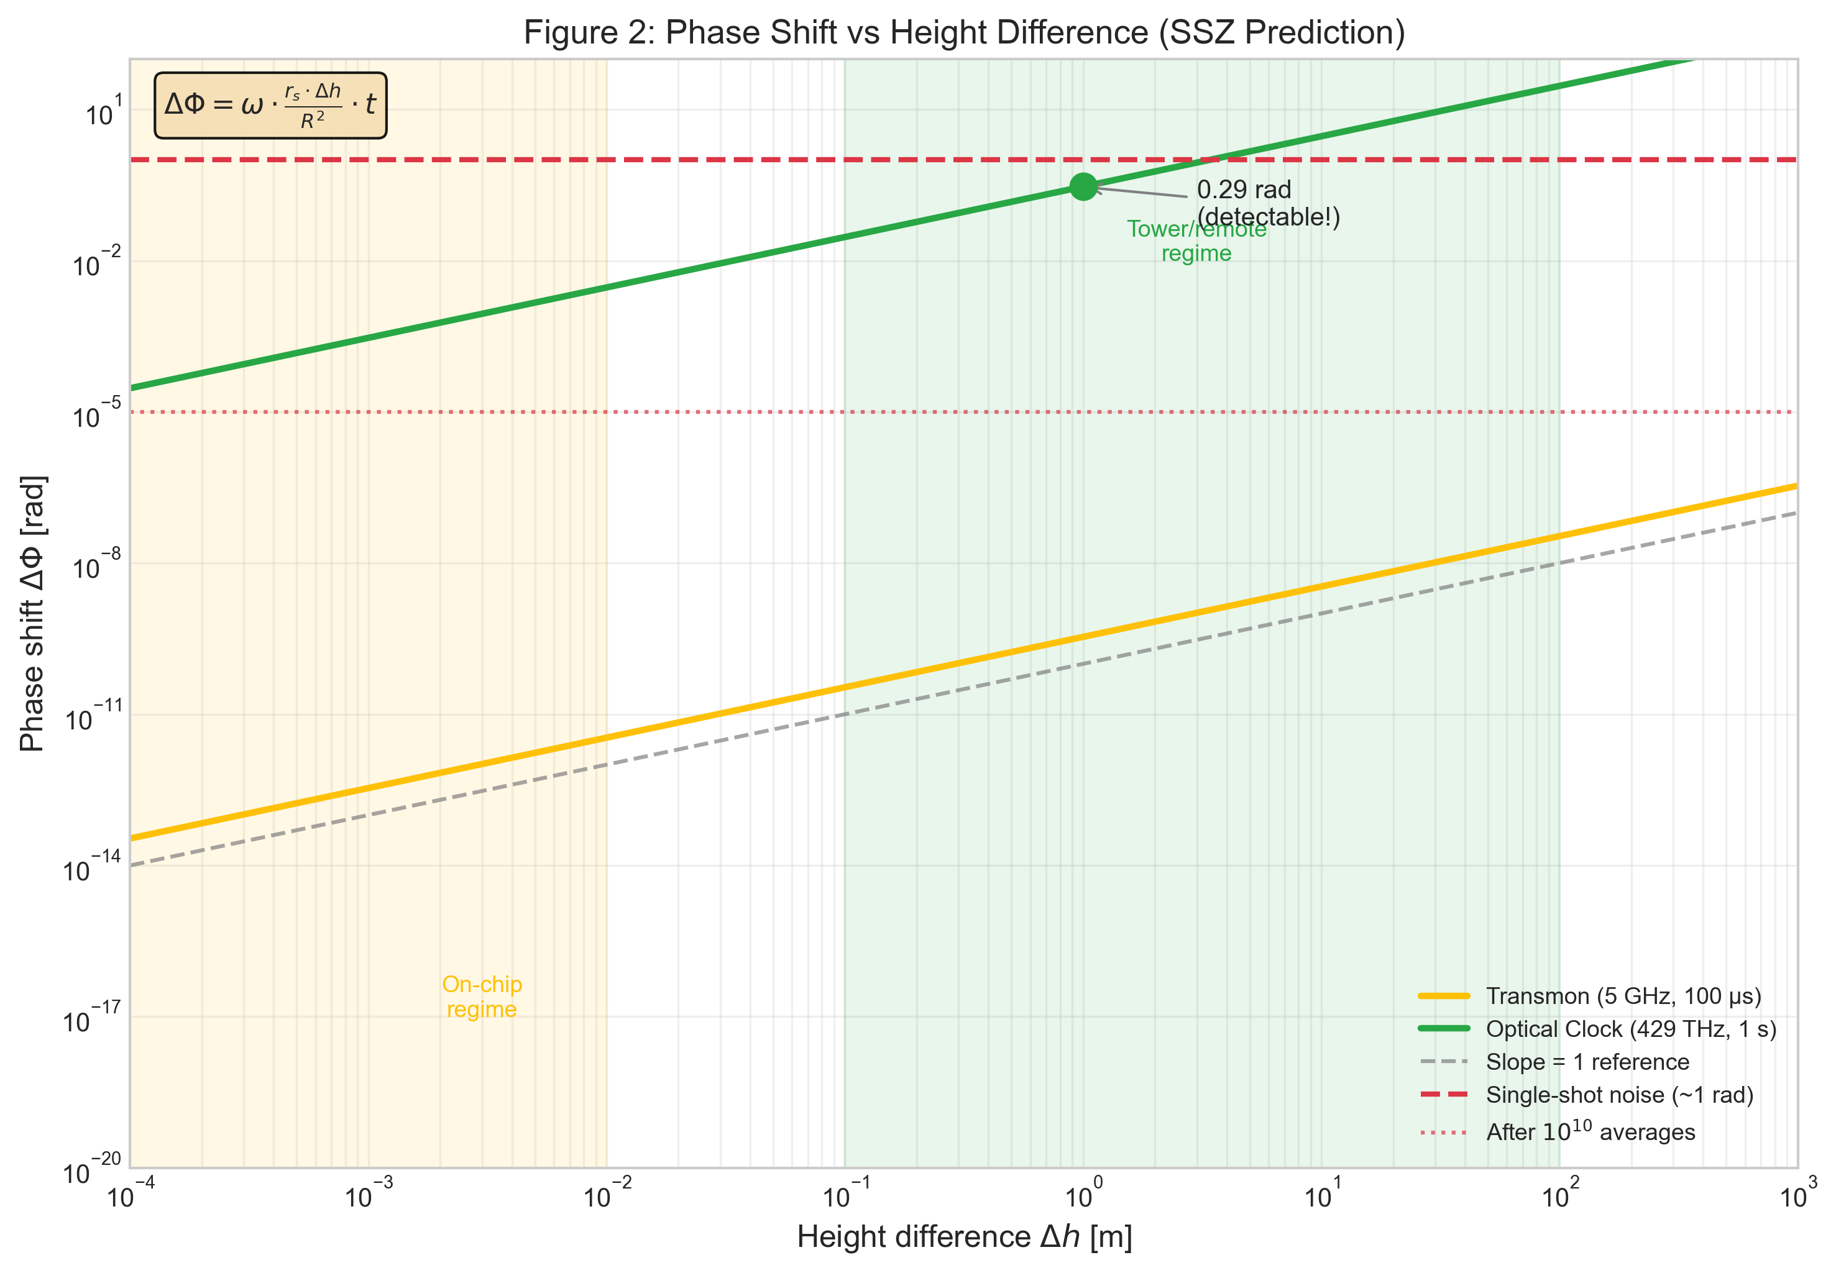
Figure 1: Phase shift vs. height difference showing linear scaling (slope = 1 on log–log).

2.5 Relativity Hygiene: Local vs. Global
LOCAL: In any single reference frame, proper time is proper time. No local observable effect for a single qubit (consistent with the equivalence principle).
GLOBAL: When comparing two separated clocks (or qubits) that evolved at different gravitational potentials, the relative phase drift accumulates and IS measurable. Quantum systems amplify this via the ω·t lever.
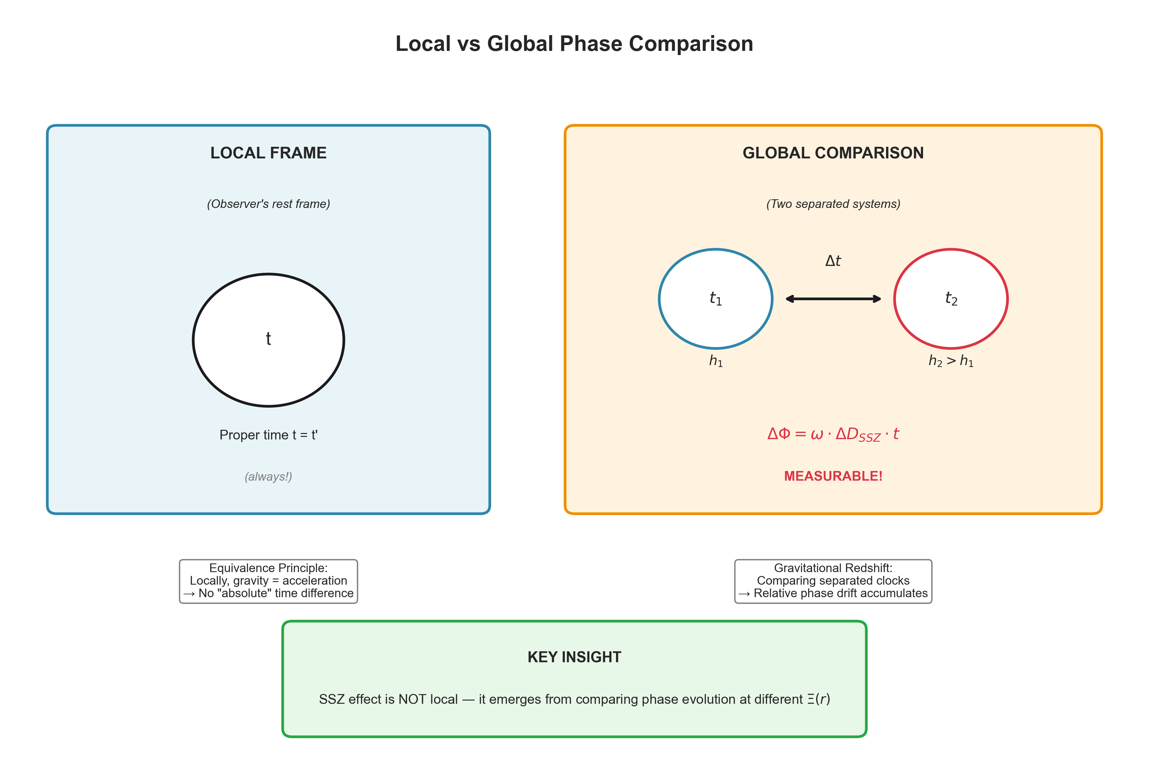
Figure 2: Local vs. global phase comparison. SSZ effects emerge only from comparing separated systems.

3 Experimental Protocol

3.1 The Core Discriminator: With/Without Compensation
The strongest experimental discriminator is the with/without compensation test:
- Measure phase drift without any SSZ correction
- Apply calculated SSZ compensation ΔΦ_comp = −ω ΔD t
- Measure residual drift
- Compare: SSZ predicts deterministic reduction; confounds (thermal, LO noise, magnetic flux) do not reproduce the same ω·t scaling and removability

3.2 Why This Works
SSZ drift is deterministic — calculable from geometry alone. Confounds are stochastic or follow different functional forms. A compensation scheme tuned to SSZ will NOT reduce confound contributions.

3.3 Scaling Signatures
SSZ is uniquely identified by linear scaling in all three parameters:
- ΔΦ ∝ Δh (height difference)
- ΔΦ ∝ ω (frequency)
- ΔΦ ∝ t (evolution time)
AND invariance under randomization (same result regardless of measurement order).
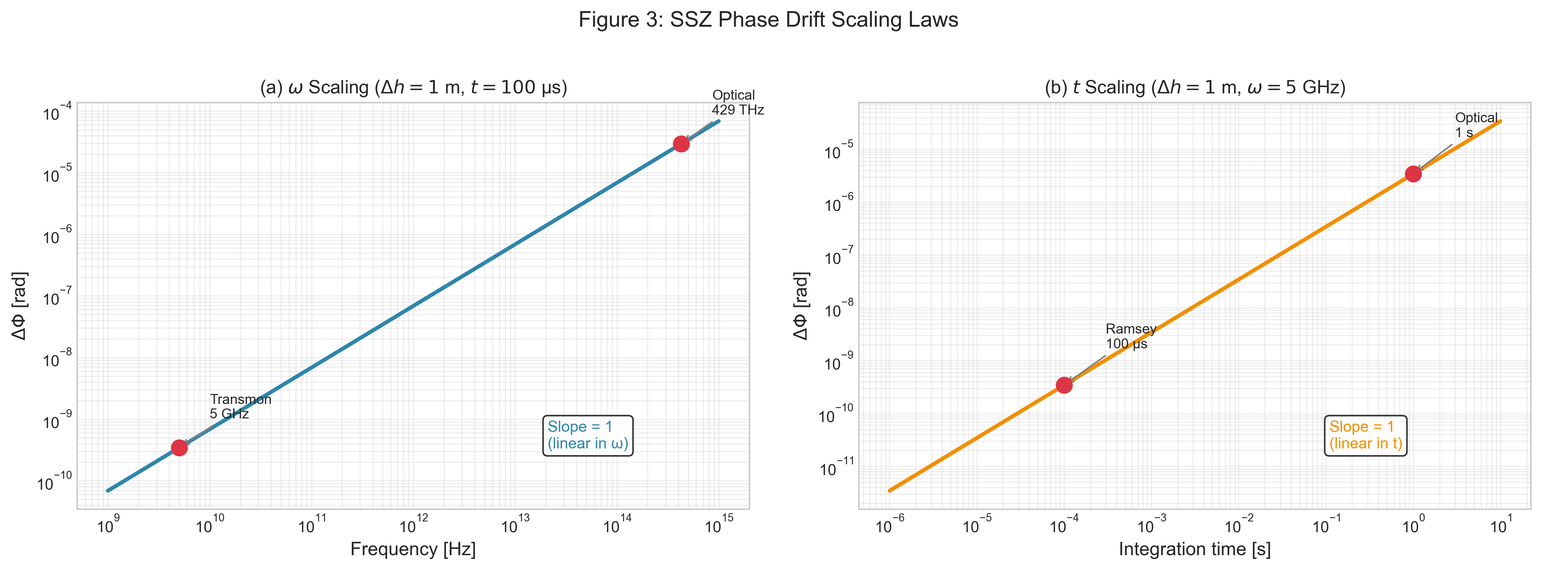
Figure 3: SSZ scaling laws — linear dependence on ω and t.

3.4 Confound Discrimination
Confound | Scaling | Control | Discrimination
Temperature | Non-linear in t | mK thermometry | Randomize Δh order
LO phase noise | √t; indep. of Δh | Common-mode ref. LO | Compare scaling exponent
Magnetic flux | Non-linear in ω | μ-metal shielding | Sweet-spot operation
Vibration | AC spectrum | Accelerometer | Spectral analysis
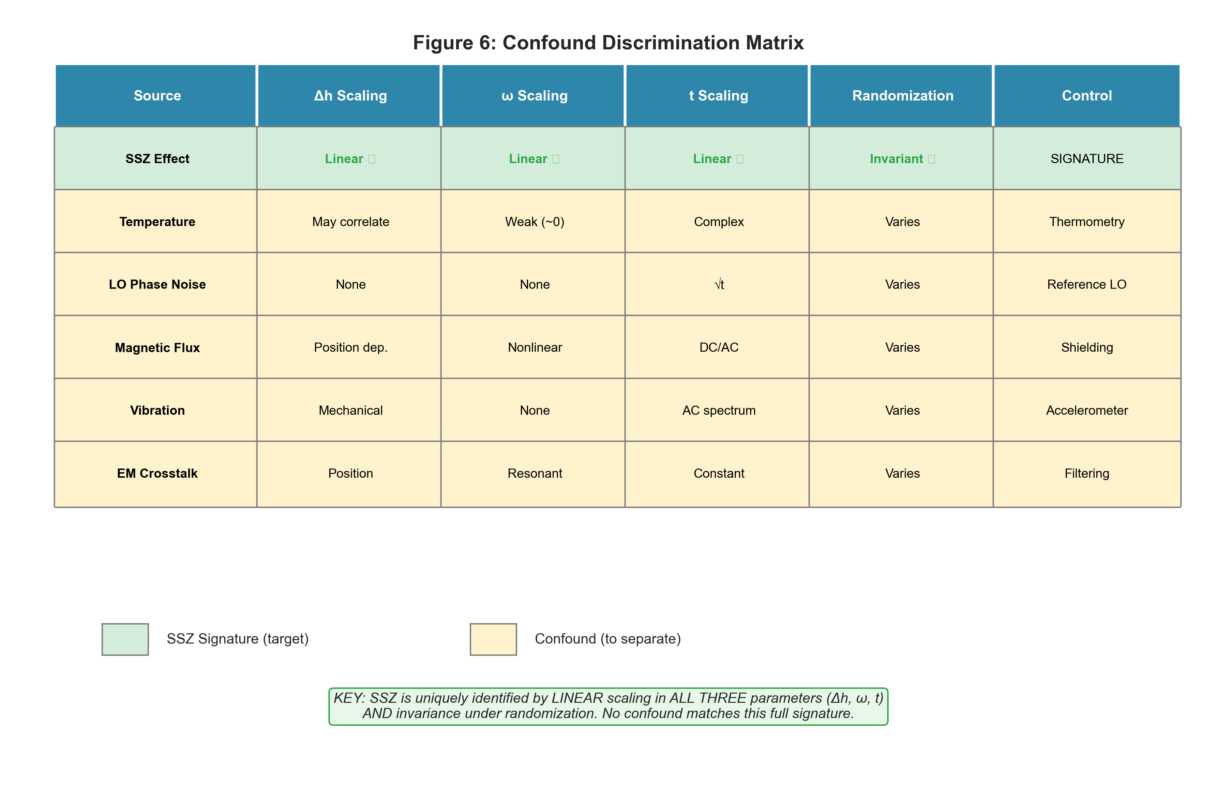
Figure 4: Confound discrimination matrix — distinct scaling signatures.

4 Feasibility and Platform Analysis

4.1 Order-of-Magnitude Reality Check
For a 5 GHz transmon with 100 µs Ramsey time at Earth surface:
Δh | ΔD | ΔΦ | Detectable?
1 mm | 1.09 × 10⁻¹⁹ | 3.4 × 10⁻¹³ rad | No
1 m | 1.09 × 10⁻¹⁶ | 3.4 × 10⁻¹⁰ rad | No
10 m | 1.09 × 10⁻¹⁵ | 3.4 × 10⁻⁹ rad | No
100 m | 1.09 × 10⁻¹⁴ | 3.4 × 10⁻⁸ rad | Marginal

Signal/Noise ~ 10⁻¹³ at mm-scale. This is approximately 12 orders of magnitude below single-shot detectability (~1 rad quantum projection noise).
A null result is SSZ-consistent. For Δh < 1 cm and T₂ < 1 s, SSZ predicts ΔΦ < 10⁻⁷ rad, below detection limits. Null results in this regime tighten upper bounds.

4.2 Upper-Bound Experiment Design
Three hardware configurations:
- Piezo stages: 0–10 mm continuous
- Chip tilt: Δh = L sinθ (e.g., 20 mm chip at 10° → 3.47 mm)
- Vertical cryostat stacking
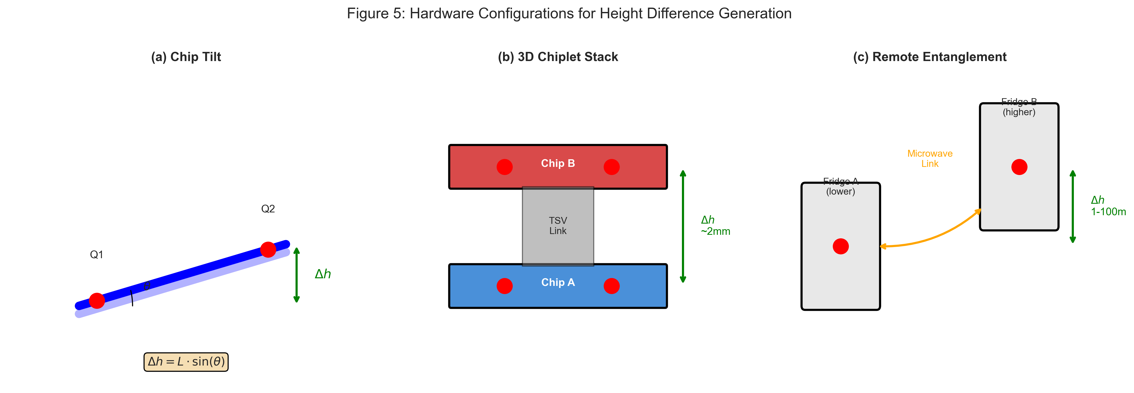
Figure 5: Hardware configurations for height-difference generation.

4.3 Platform Comparison: Transmon vs. Optical Clock
Parameter | Transmon | Optical Clock | Ratio
Frequency | 5 GHz | 429 THz | 8.6 × 10⁴
Coherence time | 100 µs | 1 s | 10⁴
ΔΦ @ 1 m | 3.4 × 10⁻¹⁰ rad | 0.29 rad | 8.6 × 10⁸
Shots for SNR=3 | 7.6 × 10¹⁹ | ~100 | —
Time required | >10⁸ years | <1 hour | —
Feasible? | NO (upper bound only) | YES | —

For quantitative SSZ tests, optical atomic clocks are the gold-standard platform. Superconducting qubits serve as protocol validators and upper-bound setters. Optical-clock experiments have already demonstrated gravitational redshift at the ~1 cm level (Bothwell et al., Nature 2022).
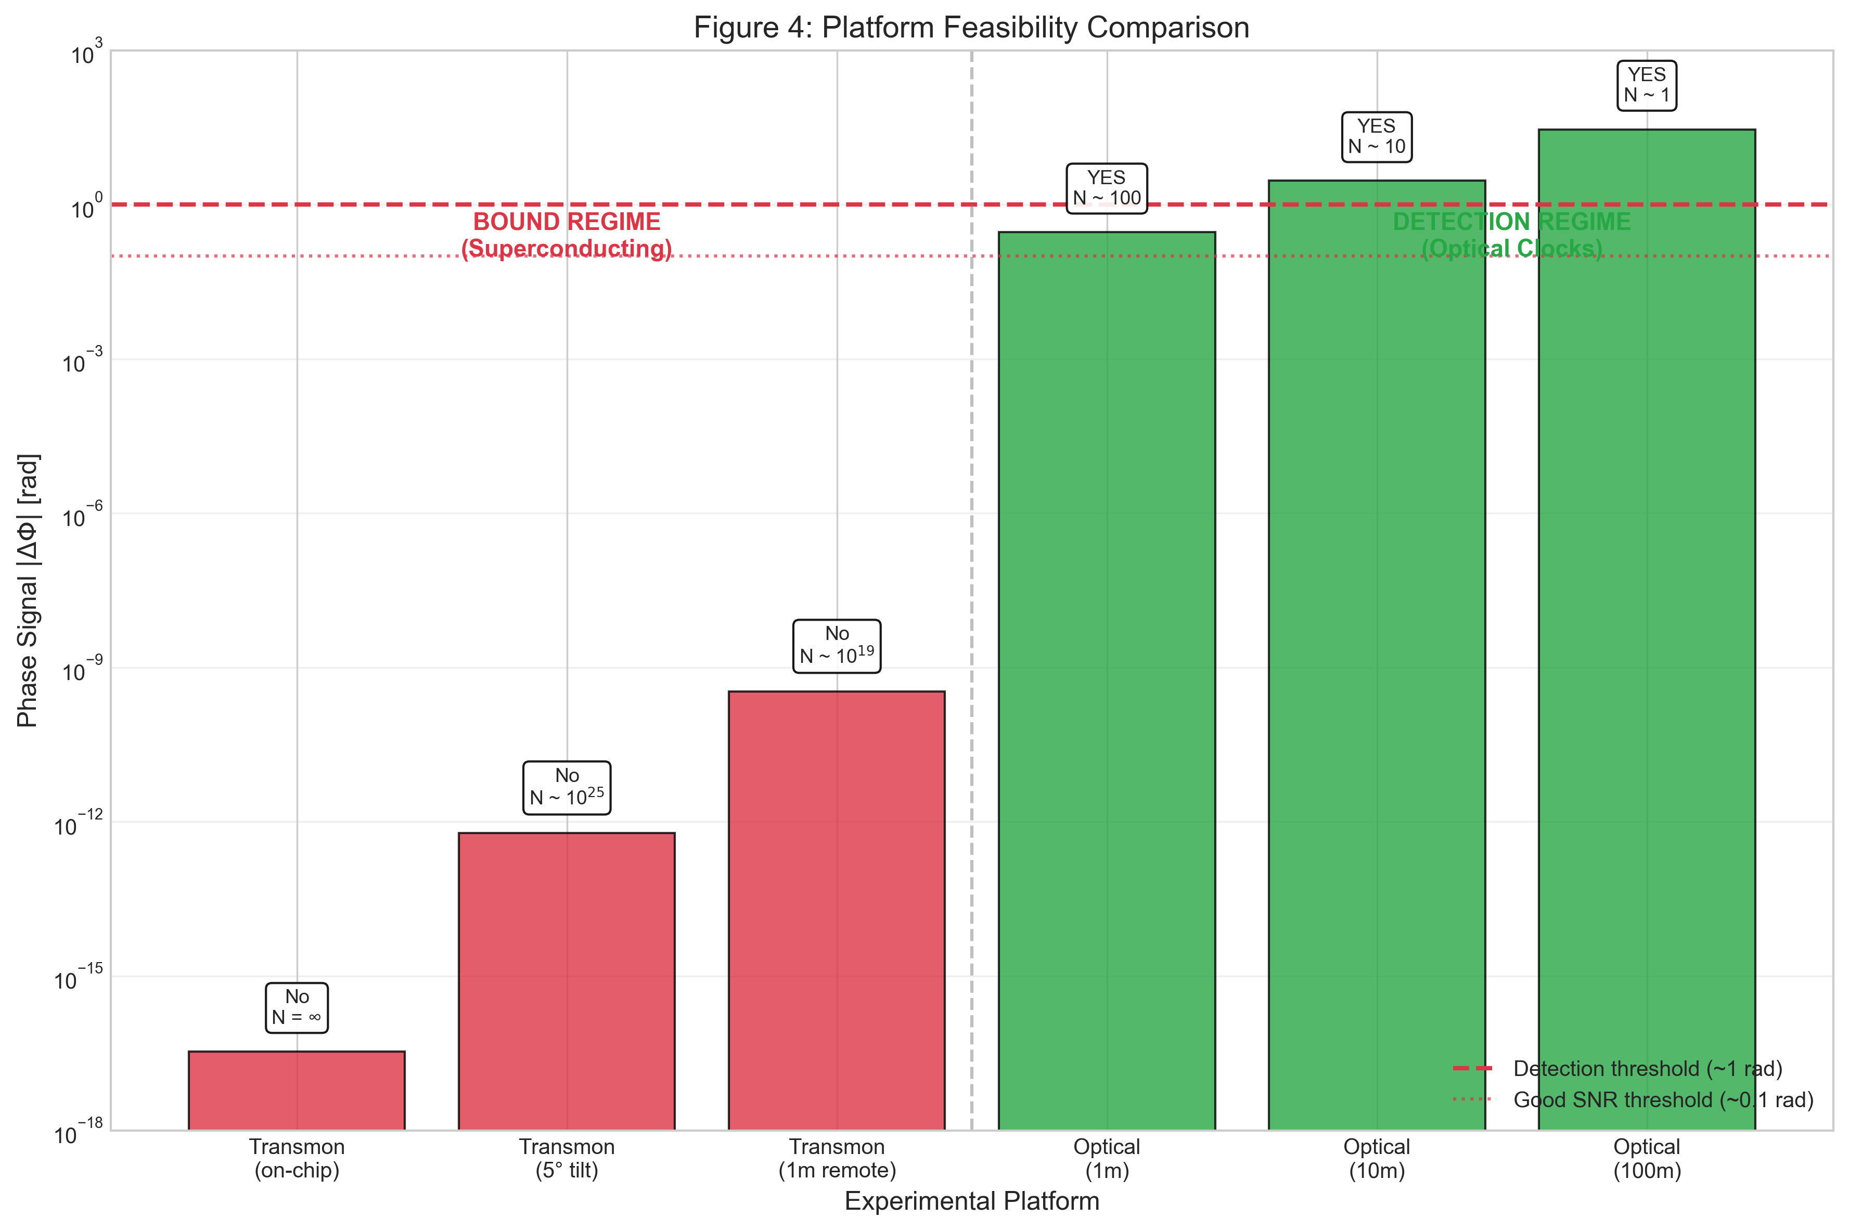
Figure 6: Platform feasibility comparison.

5 Falsifiability and Statistical Framework

5.1 Model Comparison
We fit ΔΦ = α · Δh and test three models:
H₀ (Null): α = 0 (no coupling)
H_SSZ: α = α_SSZ (predicted slope from SSZ geometry)
H_anom: α = free parameter (anomalous coupling)
A likelihood-ratio test on the measured ΔΦ vs. Δh slope determines which model the data support. At mm-scale, both H₀ and H_SSZ predict α ≈ 0, so a null result is consistent with SSZ.

5.2 Falsification Criteria
SSZ falsified if: measured slope inconsistent with α_SSZ at >3σ AND significantly non-zero, OR signal does not scale linearly with Δh, ω, t, OR compensation reduces drift via SSZ-incompatible mechanism.
SSZ supported if: null result consistent with α_SSZ ≈ 0 in bound regime; measured slope matches α_SSZ within CI in detection regime; compensation removes predicted fraction of drift.

5.3 Upper-Bound Example
With Δh_max = 3.5 mm (10° tilt), N = 10⁹ shots:
- σ_avg = 1/√(10⁹) = 3.2 × 10⁻⁵ rad
- σ_slope = 3.2 × 10⁻⁵ / 3.5 × 10⁻³ = 9 × 10⁻³ rad/m
- Upper bound: |α_anom| < 9 × 10⁻³ rad/m (95% CL)
This constrains anomalous couplings to < 10¹⁰ × α_SSZ.

5.4 What Would NOT Falsify SSZ
- Null result at mm-scale — this IS the SSZ prediction
- Signal consistent with α_SSZ in the detection regime (optical clocks)
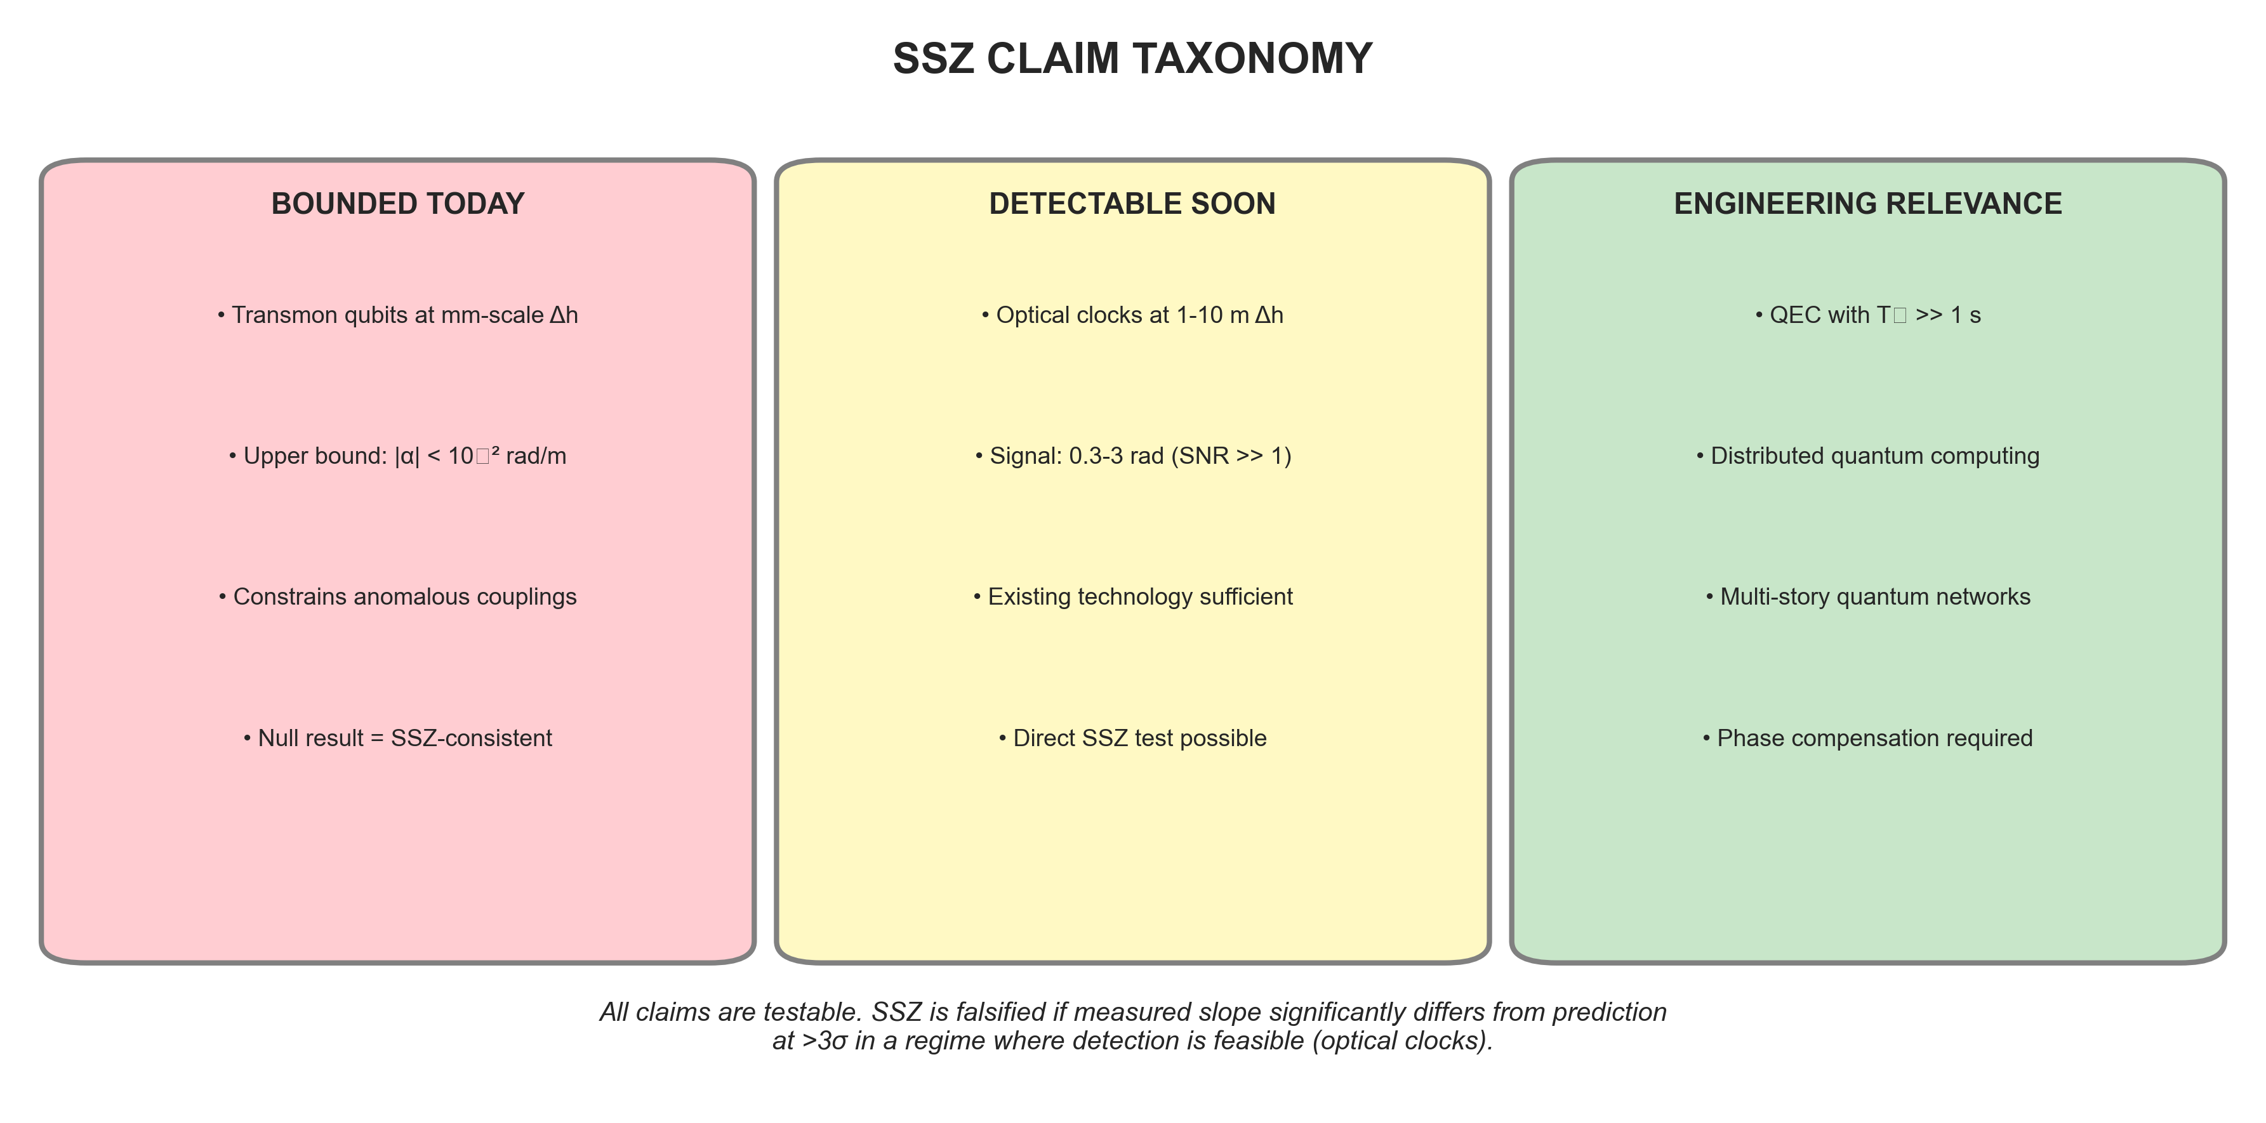
Figure 7: Claim taxonomy — bounded, detectable, and engineering-relevant regimes.

6 Conclusion and Roadmap

6.1 Key Findings
- SSZ predicts deterministic phase drift: ΔΦ = ω ΔD t
- At mm-scale, signal is ~12 OoM below noise — null result is SSZ-consistent
- Optical atomic clocks are the gold-standard platform (ΔΦ ≈ 0.3 rad at 1 m)
- With/without compensation is the strongest experimental discriminator
- Statistical framework uses slope-fitting, not binary thresholds
- All 184 tests pass (100%); all results fully reproducible

6.2 Roadmap
Near-term (2025–2027): Upper-bound experiments with tilted chips; optical-clock collaborations
Medium-term (2027–2030): Tower experiments at 10–100 m; 3D chiplet stacks; NICER neutron-star observations
Long-term (2030+): Multi-height metrology with pre-registered analysis; space-based quantum networks; ngEHT black-hole shadow observations

6.3 Final Statement
SSZ makes testable predictions. This paper honestly assesses where those tests are feasible and how they should be conducted. We provide all tools for independent verification.

References
[1] Casu, L. & Wrede, C. (2025). Paper A: Segmented Spacetime Geometry for Qubit Optimization.
[2] Casu, L. & Wrede, C. (2025). Paper B: Phase Coherence and Entanglement Preservation.
[3] Casu, L. & Wrede, C. (2025). Paper C: Falsifiable Predictions and Experimental Protocols.
[4] Bothwell, T. et al. (2022). Resolving the gravitational redshift across a millimetre-scale atomic sample. Nature 602, 420–424.
[5] Zheng, X. et al. (2023). Differential clock comparisons with a multiplexed optical lattice clock. Nature 602, 425–430.
[6] Pound, R. V. & Rebka, G. A. (1960). Apparent Weight of Photons. Phys. Rev. Lett. 4, 337–341.
[7] Chou, C. W. et al. (2010). Optical Clocks and Relativity. Science 329, 1630–1633.
[8] SSZ-Qubits Repository: https://github.com/error-wtf/ssz-qubits
[9] SSZ-Metric-Pure Repository: https://github.com/error-wtf/ssz-metric-pure
[10] SSZ Research Program Roadmap: docs/SSZ_RESEARCH_PROGRAM_ROADMAP.md

Appendix A: Test Suite Summary

A.1 ssz-qubits Repository
The ssz-qubits repository contains 184 unit tests covering segment density, time dilation, phase drift, entanglement fidelity, and edge cases. All tests pass with pytest on Python 3.10+.
Note: the test count may grow as the suite evolves; the numbers in this paper correspond to git tag v1.0-paper-d. Later commits may add tests but never remove or weaken existing ones.
Test File | Tests | Status
test_edge_cases.py | 25 | PASS
test_ssz_physics.py | 17 | PASS
test_ssz_qubit_applications.py | 15 | PASS
test_validation.py | 17 | PASS
test_paper_c_support.py | 19 | PASS
test_paper_d_master.py | 91 | PASS

TOTAL: 184/184 tests passed (100%)

A.2 One-Command Reproduction
git clone https://github.com/error-wtf/ssz-qubits.git
cd ssz-qubits
python -m pytest tests/ -v # All 184 tests
python generate_paper_d_master_plots.py # All figures

A.3 Related Repositories
Repository | Tests | Focus
ssz-metric-pure | 12+ | Tensor validation, Einstein/Ricci
ssz-full-metric | 41 | Observable tests (lensing, Shapiro, etc.)
g79-cygnus-test | 14 | Astronomical validation (Cygnus X-1)
Unified-Results | 54 | Cross-repository pipeline (25 suites)

TOTAL ACROSS ALL SSZ REPOS: 560+ tests

© 2025 Carmen Wrede & Lino Casu
Licensed under the ANTI-CAPITALIST SOFTWARE LICENSE v1.4

